## Reference links

<https://minikube.sigs.k8s.io/docs/handbook/kubectl/>

Download minikube from here

<https://github.com/kubernetes/minikube>

add miniube to ur system path , so that in your command prompt when u type echo %path%

u should be able to see the minikube .exe in your system path

## Starting minikube cluster

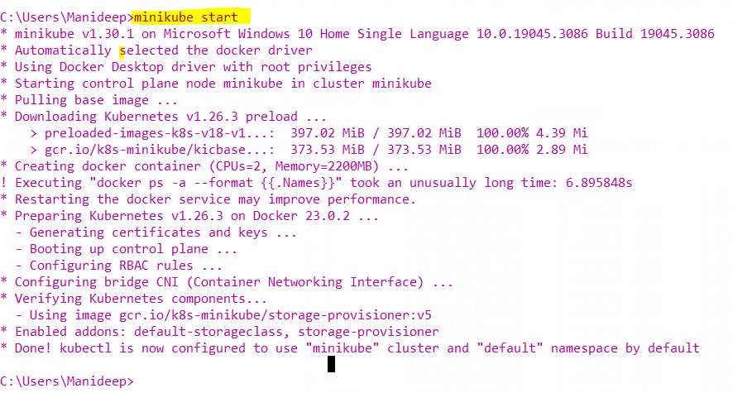

## Kubectl status

Kubectl is already installed

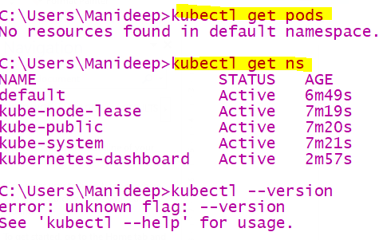

## Opening Minikube dashboard in browser

minikube dashboard

just type “”minikube dashboard” a browser window will open

## verify cluster is installed or not

“kubectl cluster-info”

